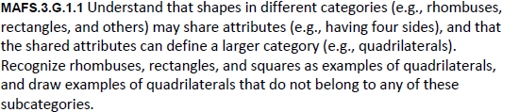
G.1.1-FSA-OR6

Teachers: Your students can type in their response in the text box below.
