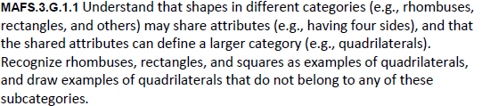
G.1.1-FSA-MC5

Multiple Choice
