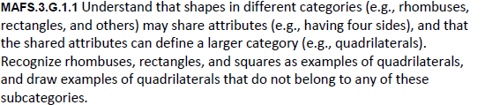
G.1.1-FSA-GR4
GRID

Teachers: Students can use the following lines to draw the shape needed in order to solve the statement.

