**SC.7.L.17.2**

Mangrove trees are common to the Florida Everglades. The tree roots serve as a place for freshwater oysters to attach when the tide is high, as shown in the picture below. The oysters are protected from predators when attached to the roots underwater.

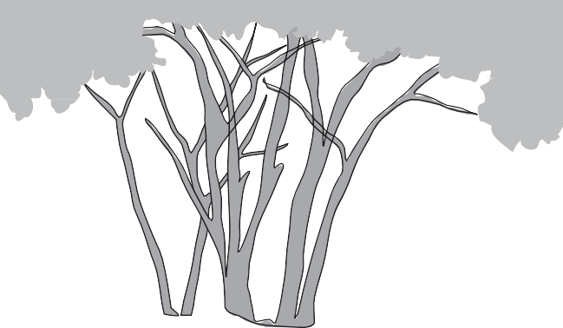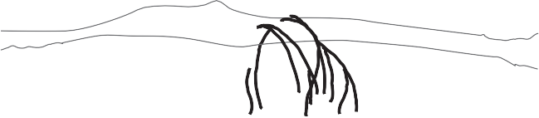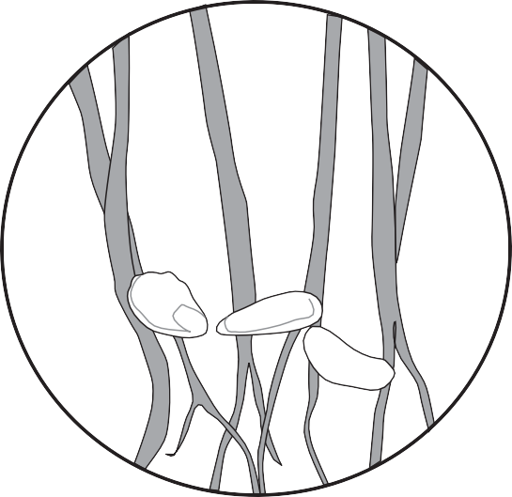

**Mangrove Tree Oysters on Mangrove Roots**

The oysters do not harm the trees nor do they provide any benefit to the trees. Which of the following relationships is **most** similar to the relationship between the mangrove trees and the oysters?

1. African ants living in acacia trees feed on leaf-eating insects found on the tree.
2. Spider crabs are camouflaged by the green-brown algae growing on their shells.
3. A whale is unaffected by the attached remora fish feeding on the whale’s leftover food.

**D.** Bees fly from one flowering plant to another gathering nectar and pollinating the flowers.

Mangrove trees are common to the Florida Everglades. The tree roots serve as a place for freshwater oysters to attach when the tide is high, as shown in the picture below. The oysters are protected from predators when attached to the roots underwater.



## Mangrove Tree Oysters on Mangrove Roots

The oysters do not harm the trees nor do they provide any benefit to the trees. Which of the following relationships is **most** similar to the relationship between the mangrove trees and the oysters?

1. African ants living in acacia trees feed on leaf-eating insects found on the tree.
2. Spider crabs are camouflaged by the green-brown algae growing on their shells.

★**C.** A whale is unaffected by the attached remora fish feeding on the whale’s leftover food.

**D.** Bees fly from one flowering plant to another gathering nectar and pollinating the flowers.