**SC.6.L.14.1**

Structures in the human body work together to perform specific functions. The diagram below shows the organization of structures found in the human body.

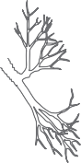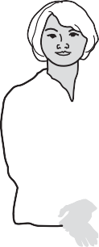

A picture of which of the following structures belongs in the box above?

1. cell
2. organ
3. organelle
4. tissue

Structures in the human body work together to perform specific functions. The diagram below shows the organization of structures found in the human body.



A picture of which of the following structures belongs in the box above?

1. cell
2. organ
3. organelle

★ **D.** tissue