MAFS.4.OA.1.3 Solve multistep word problems posed with whole numbers and having whole‐number answers using the four operations, including problems in which remainders must be interpreted. Represent these problems using equations with a letter standing for the unknown quantity. Assess the
reasonableness of answers using mental computation and estimation strategies including rounding.

OA.1.2-FSA-OR4
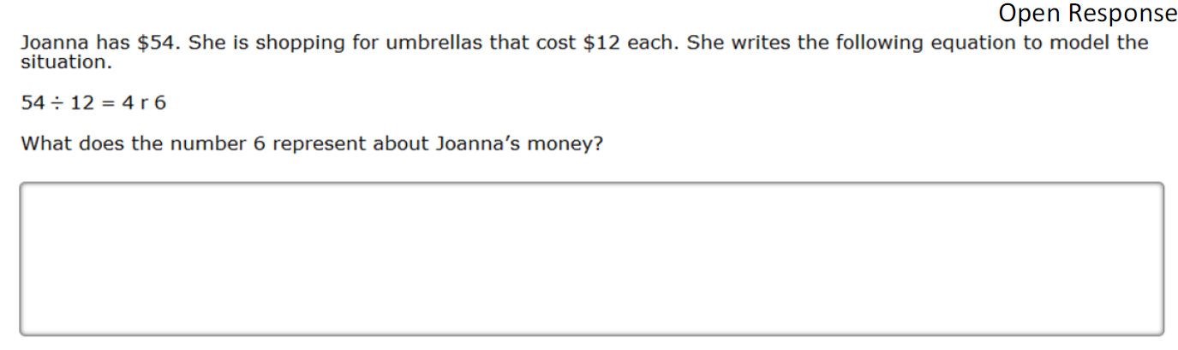

Teachers Note: Students can type in their response in the above box.

