MAFS.3.OA.2.6 Understand division as an unknown‐factor problem. For example, find 32 ÷ 8 by finding the number that makes 32 when multiplied by 8.

OA.2.6-FSA-GR2
GRID

Teachers: Students have the capability of dragging and dropping the items to begin practicing for (TEI) Technology Enhanced Items.
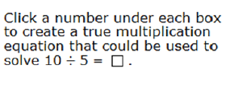
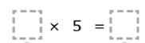

2
2

5
5

10
10

