**MAFS.3.OA.1.4** Determine the unknown whole number in a multiplication or division equation relating three whole numbers. *For example, determine the unknown number that makes the equation true in each of the equations 8 × ? = 48, 5 = _ ÷ 3, 6 × 6 = ?*

OA.1.4-FSA-MC3

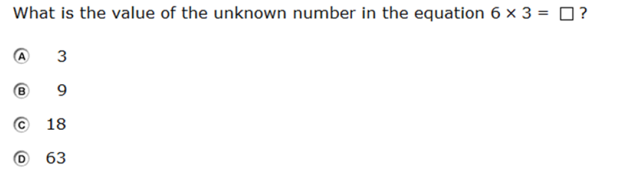

Multiple Choice