MAFS.3.OA.1.1 Interpret products of whole numbers, e.g., interpret 5 × 7 as the total number of objects in 5 groups of 7 objects each. For example, describe a context in which a total number of objects can be expressed as 5 × 7.
OA.1.1-FSA-OR1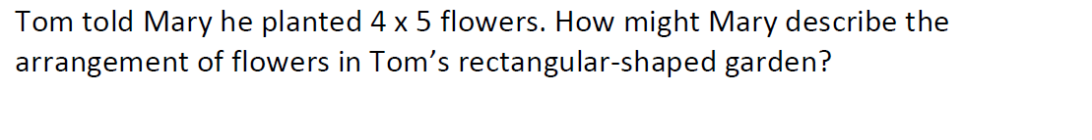
Open Response
Teachers: Students can respond to this question in the text box below.

