MAFS.3.OA.1.1 Interpret products of whole numbers, e.g., interpret 5 × 7 as the
total number of objects in 5 groups of 7 objects each. For example, describe a
context in which a total number of objects can be expressed as 5 × 7.

OA.1.1-FSA-MC2

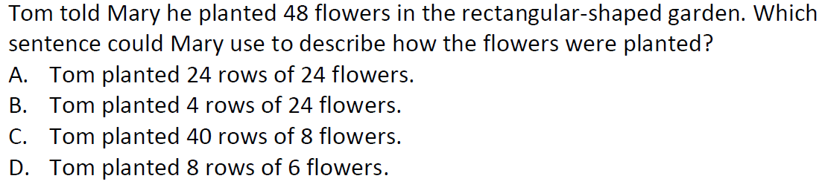

Multiple Choice

