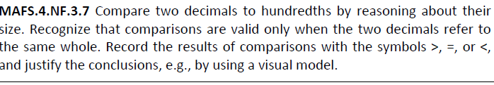

NF.3.7-FSA-OR5
Open response

Teachers: Your students can type in their response in the text box below.

