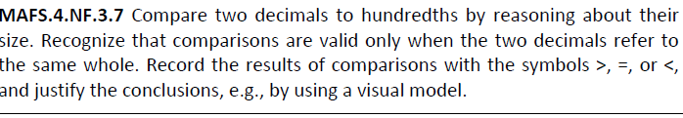

NF.3.7-FSA-MI4
Matching Item
Teacher NOTE Students can use the blue dot to drag and drop for the matching problem.

