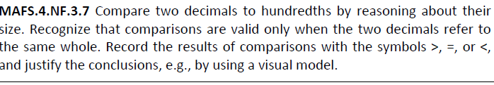

NF.3.7-FSA-GR7
GRID
Teachers NOTE Students can drag and drop a number into the box to complete the comparison problem.

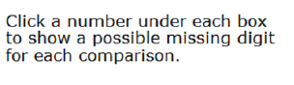

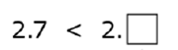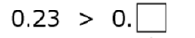

0
1
2
3
4
5
6
7
8
9

