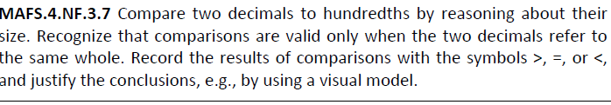

NF.3.7-FSA-GR2
GRID
Teachers NOTE Students can drag the number and the arrow to the location on the number line. Students can drag the comparison symbol to complete this problem.

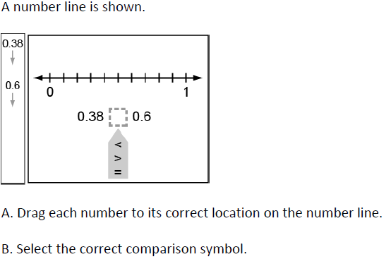
0.6
0.38
<>
>
=

