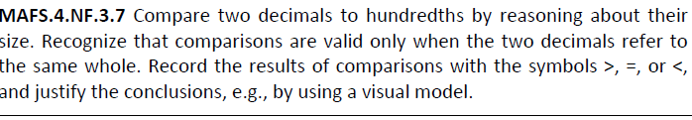

NF.3.7-FSA-GR1
GRID
Teachers NOTE Students can drag and drop the colored squares to shade sections to represent the numbers. They can also drag and drop the correct symbol to compare numbers.






