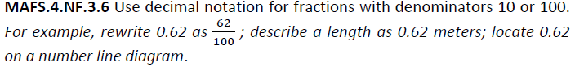

NF.3.6-FSA-GR1
GRID

Teachers NOTE Students can use the red dot by dragging and dropping the dot onto the number line in order to plot the points for the values.

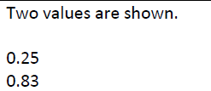

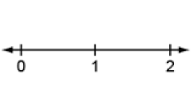
0.83
0.2525

