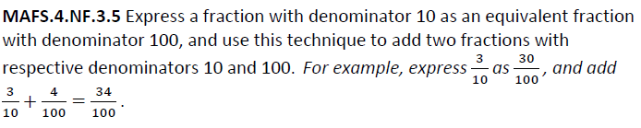

NF.3.5-FSA-MC2
Multiple Choice

