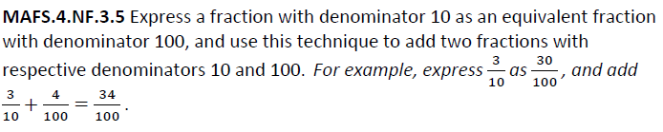

NF.3.5-FSA-EE3
Equation Editor

Teachers, in order for students to be able to practice this Technology-Enhanced Item (TEI) Type for the FSA, have them access the given hyperlink. The” Equation Editor” tutorial on the FSA portal can be used to solve this sample item. After the initial link to the portal, students would need to click the green Next arrow.

http://demo.tds.airast.org/eqtutorial/?c=florida_pt&language=true#

Students would then select options from the two drop down menus.
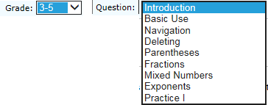
NOTE: Based on the given information in the item, the teacher would need to direct students as to which selection to make in the Question drop down menu because the Editor may be slightly different for each.

