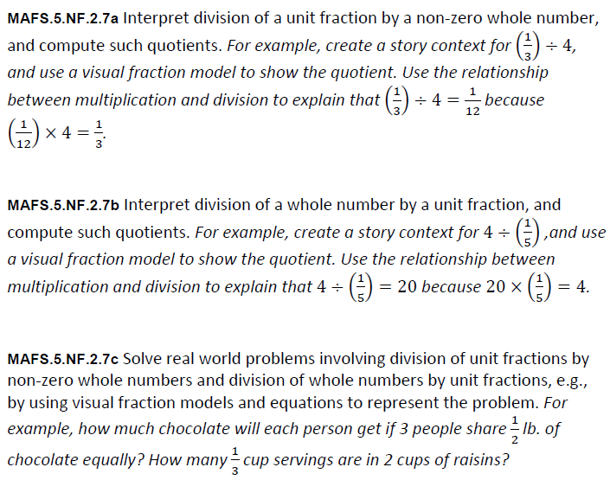
NF.2.7abc-FSA-GR4
GRID
Teachers: NOTE Students will use the dot to place on the number line to create sections for the model.
Students will use the circle to choose the number of bags that Julio can make.
Julio has 6 pounds of candy. He wants to put the candy into bags so that each bag has ½ pound of candy.
Click on the number line to create sections that model how Julio can put all the candy evenly into bags.
Click on the total number of bags that Julip can make.
