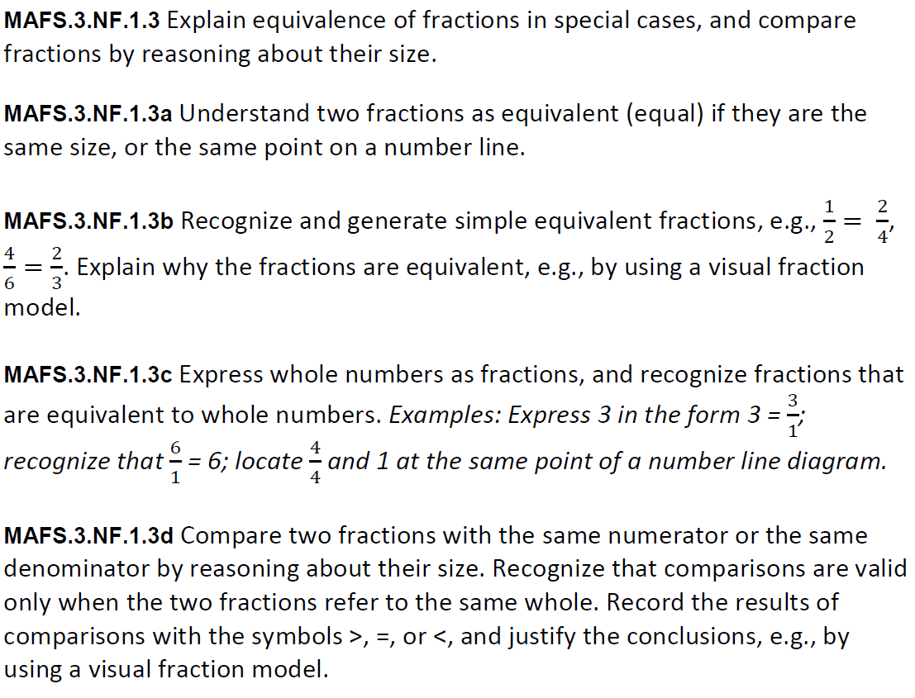
NF.1.3MS5
Multiselect
Teachers, in order for students to be able to practice the Multi-Select Technology-Enhanced Item (TEI) Type for the FSA, students would drag the check marks (below the problem) to the boxes that are given in order for them to show their answer choices.
Keep in mind that all correct answers must be selected for a student to receive any credit for the item.

