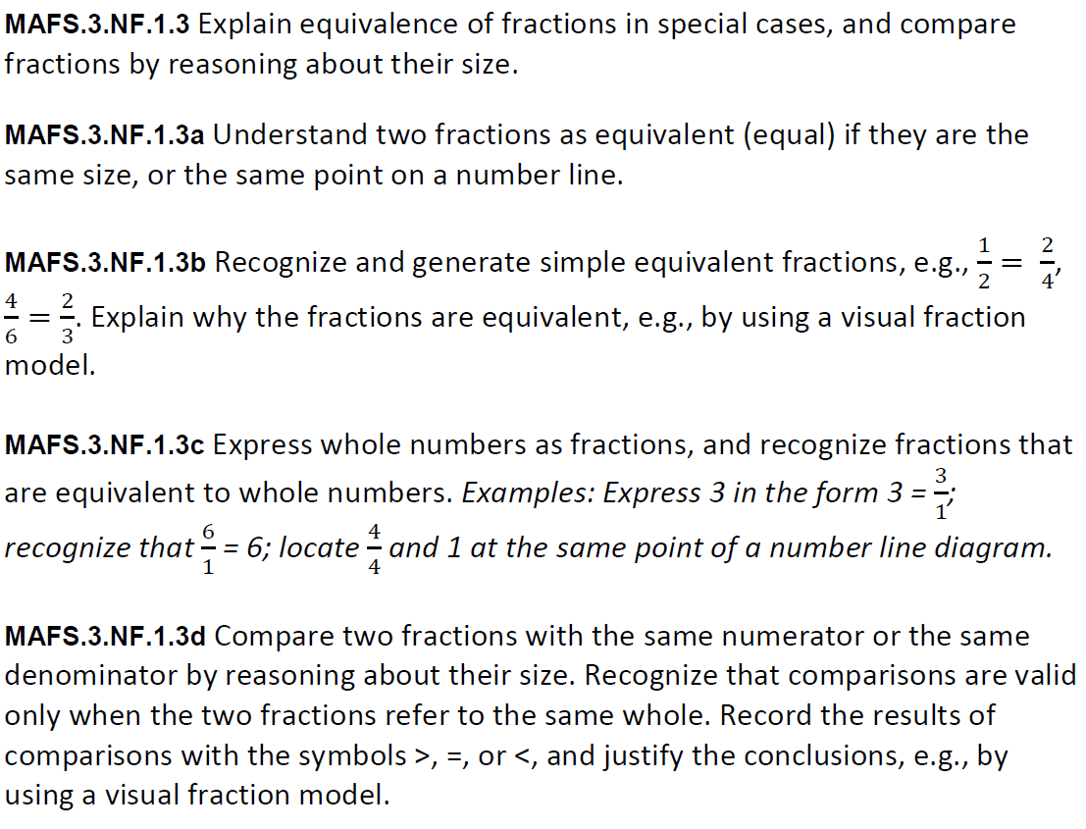
NF.1.3GR4
GRID
Teachers:NOTE Students have the ability to shade sections using the line provided. The line will lengthen or shorten accordingly. The student can use the numbers below to create the fraction

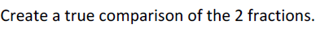
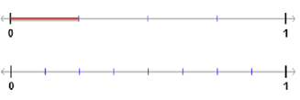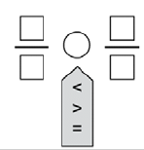

3
0
1
2
4
5
6
7
8
9

