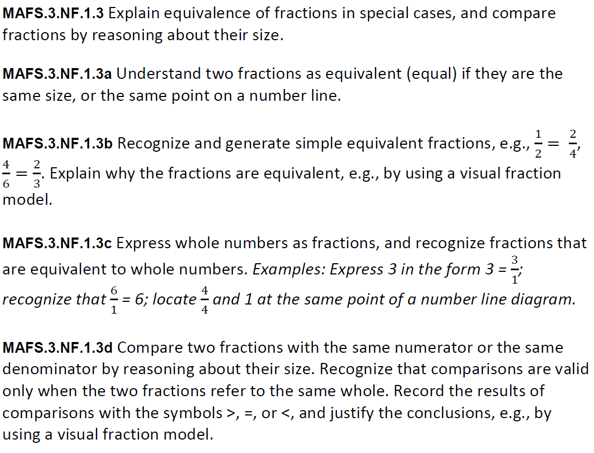
NF.1.3abcd-FSA-GR2
GRID
Teachers: Students have the capability of dragging and dropping the items to begin practicing for (TEI) Technology Enhanced Items.
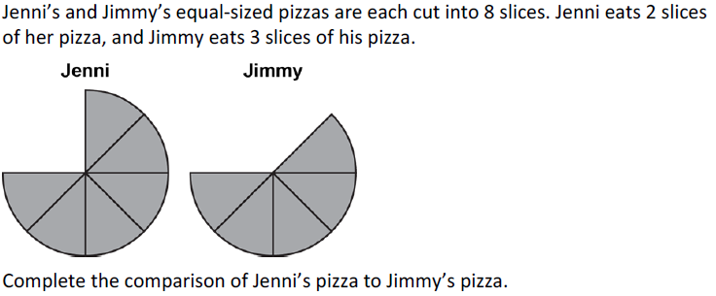
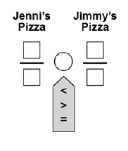
900
800
700
600
00
500
400
300
20
10

