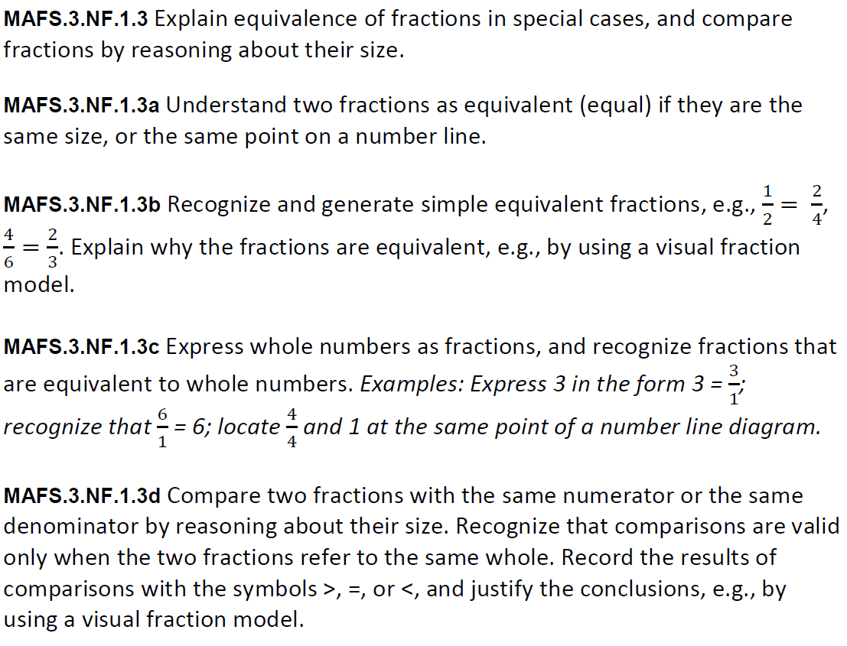
NF.1.3abcd-FSA-GR1
GRID
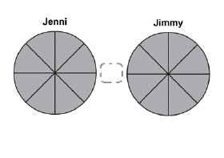
Students can drag and drop the symbols to make a true statement.
≤
=₌=
≥

