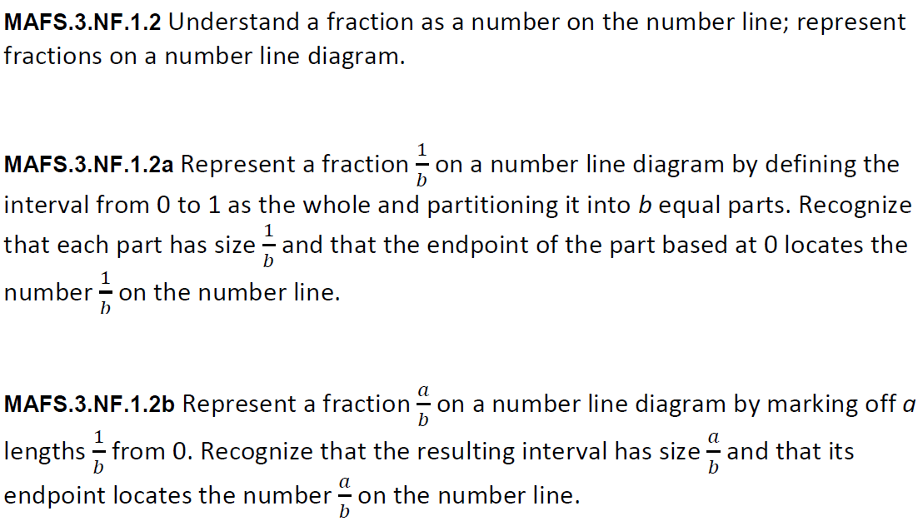
NF.1.2ab-FSA-GR4
GRID
Teachers: Students have the capability of dragging and dropping the items to begin practicing for (TEI) Technology Enhanced Items.

Drag the fraction to show its correct location on the selected number line.
$$\frac{3}{4}$$

