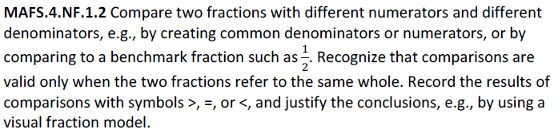
NF.1.2-FSA-OR1
Teachers: Your students can type in their response in the text box below.
Open Response
