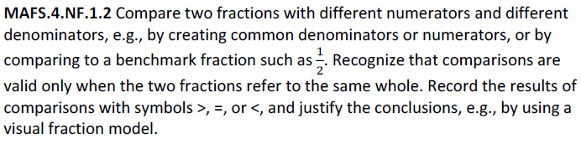

NF.1.2-FSA-MI2
Matching Item

Teachers NOTE: Students can use the blue dot and drag and drop in order to complete the matching items for this problem.

