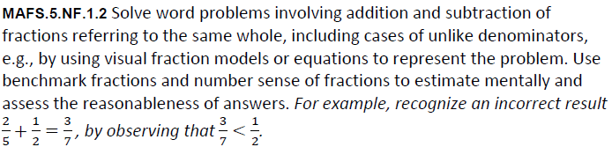

NF.1.2-FSA-MC4
Multiple Choice
