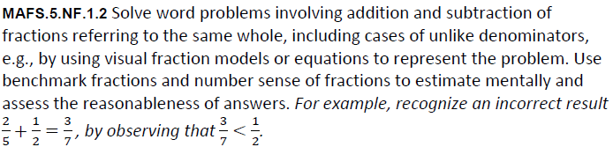

NF.1.2-FSA-MC3
Multiple Choice


