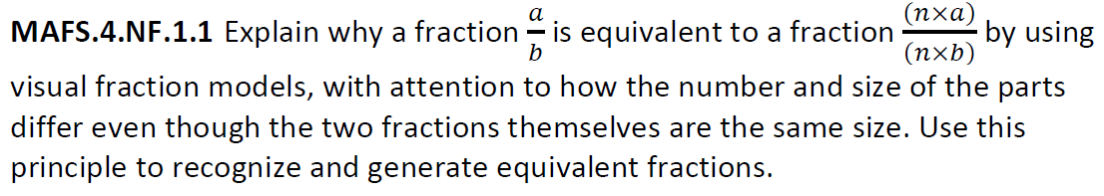
NF.1.1-FSA-MC4
Multiple Choice



