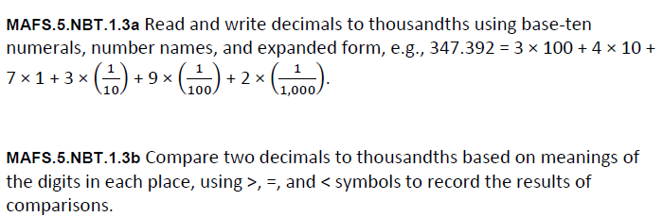
NBT.1.3ab-FSA-MI2
Matching Item

Teacher: Have the student move the oval symbol to the correct number name.
