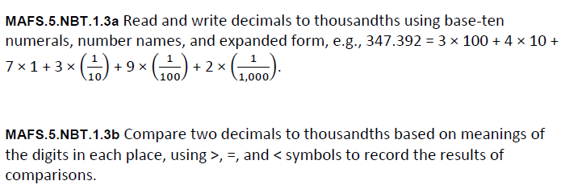
NBT.1.3ab-FSA-MC1
Multiple Choice
