**MAFS.4.NBT.1.2** Read and write multi‐digit whole numbers using base‐ten numerals, number names, and expanded form. Compare two multi‐digit numbers based on meanings of the digits in each place, using >, =, and < symbols to record the results of comparisons

NBT.1.2-FSA-MI3

Matching Item

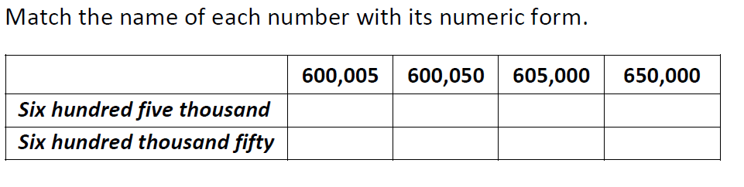

**Teachers NOTE Students can drag and drop the blue dot to match the words with the corresponding number.**