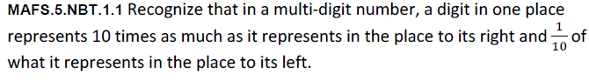
NBT.1.1-FSA-MC2
Multiple Choice
