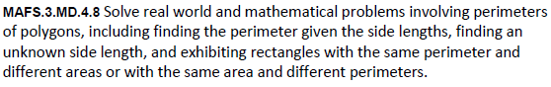

MD.4.8-FSA-MC1
Multiple Choice


