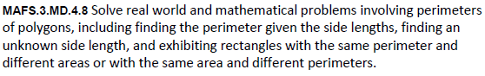
MD.4.8-FSA-GR54
GRID
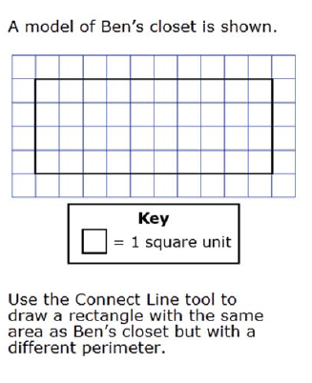
Teachers: NOTE Students can use the lines given to draw the shape needed to solve this problem. The lines will lengthen or shorten as needed for the model.
