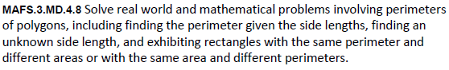

MD.4.8-FSA-GR4
GRID
Teachers NOTE: Students will fill in the text boxes with numbers to solve the problem.

