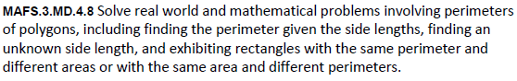

MD.4.8-FSA-GR2
GRID
Teachers NOTE: Students will fill in the text boxes with numbers that would solve the problem.

