MAFS.4.MD.3.7 Recognize angle measure as additive. When an angle is decomposed into non‐overlapping parts, the angle measure of the whole is the sum of the angle measures of the parts. Solve addition and subtraction problems to find unknown angles on a diagram in real world and mathematical problems, e.g., by using an equation with a symbol for the unknown angle measure.

MD.3.7-FSA-MI2
Matching Item
Teachers: Students have the capability of dragging and dropping the items to begin practicing for (TEI) Technology Enhanced Items.

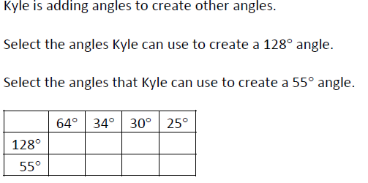
Teachers NOTE Students can use the blue dots in order to match the items.

