**MAFS.4.MD.3.5** Recognize angles as geometric shapes that are formed wherever two rays share a common endpoint, and understand concepts of angle measurement.

**MAFS.4.MD.3.5a** An angle is measured with reference to a circle with its center at the common endpoint of the rays, by considering the fraction of the circular arc between the points where the two rays intersect the circle. An angle that turns through 1/360 of a circle is called a “one‐degree angle,” and can be used to measure angles.

**MAFS.4.MD.3.5b** An angle that turns through *n* one‐degree angles is said to have an angle measure of *n* degrees.

MD.3.5ab-FSA-EE3

Equation Editor

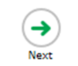Teachers, in order for students to be able to practice this Technology-Enhanced Item (TEI) Type for the FSA, have them access the given hyperlink. The” Equation Editor” tutorial on the FSA portal can be used to solve this sample item. After the initial link to the portal, students would need to click the green Next arrow.

[http://demo.tds.airast.org/eqtutorial/?c=florida_pt&language=true#](http://demo.tds.airast.org/eqtutorial/?c=florida_pt&language=true)

Students would then select options from the two drop down menus.

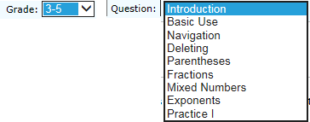***NOTE: Based on the given information in the item, the teacher would need to direct students as to which selection to make in the Question drop down menu because the Editor may be slightly different for each.***

