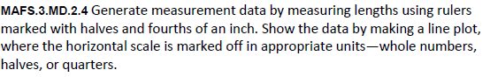
MD.2.4-FSA-GR4
GRID
Teachers: NOTE students can use the X’s to drag and drop into the boxed to create a line plot for the data.
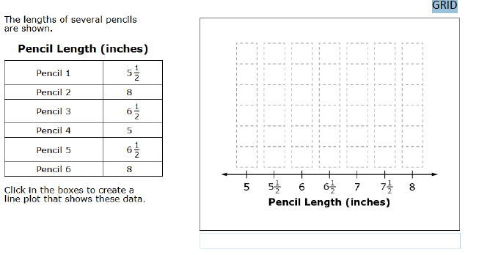

X
X
X
X
X
X
X
X
X
X

