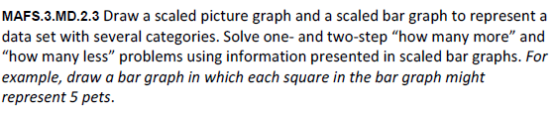
MD.2.3-FSA-GR4
GRID
Teachers: Students have the capability of dragging and dropping the items to begin practicing for (TEI) Technology Enhanced Items.

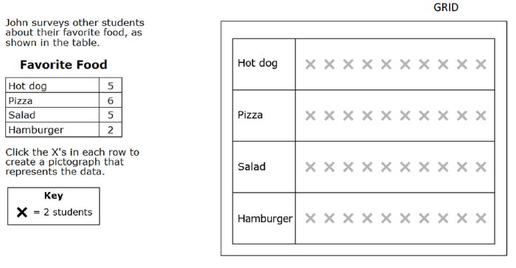
X
X
X
X
X
X
X
X
X
X
X
X
X
X
X
X
X
X

NOTE:
Drag the X’s to create the pictograph that represents the data.

