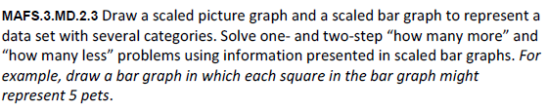
MD.2.3-FSA-GR3
GRID
Teachers: Note students can practice this item using the bars below to represent the data. The bars can be lengthened or shortened as needed to complete the graph.
