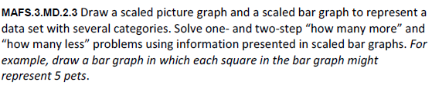
MD.2.3-FSA-GR1
GRID
Teachers: Students have the capability of dragging and dropping the items to begin practicing for (TEI) Technology Enhanced Items.

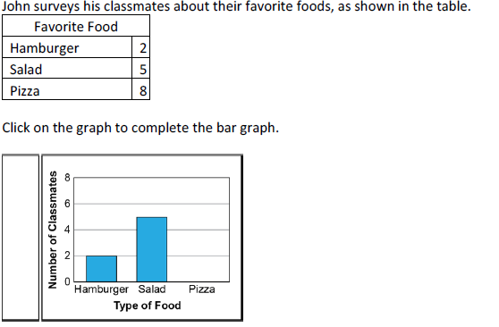
The bars can be lengthened or shortened as needed to complete the graph.

