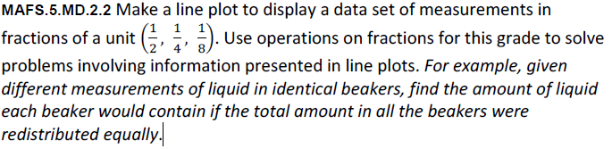

Equation Editor
MD.2.2-FSA-MC4

