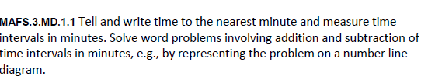
MD.1.TI3
Table Item
Teachers, you may use the item below as an actual “complete the table” item since there are text boxes available in the table for filling in the numbers. This will enable the students to have practice with this type of Technology-Enhanced Item (TEI) Type.

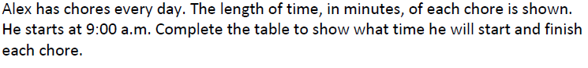
Students will fill in the blue boxes with the times to complete the table.

