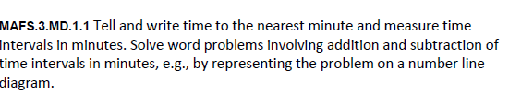
MD.1.1-FSA-MC4
Multiple Choice



