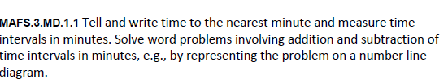
MD.1.1GR1
GRID

