G.1.2-FSA-GR9
GRID
Teachers: Students have the capability of dragging and dropping the items to begin practicing for (TEI) Technology Enhanced Items.
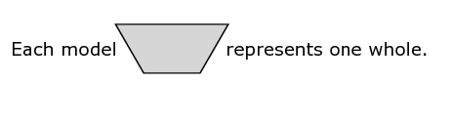

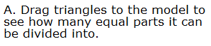

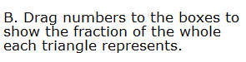
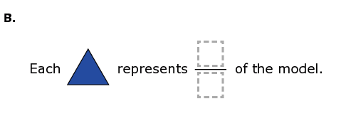
5
8
9
0
1
2
3
4
6
7

