**MAFS.912.N-RN.1.1**

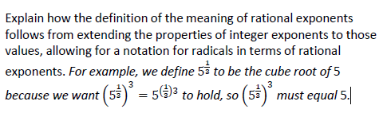

**Item Type**

**Multiple Choice**

