MAFS.912.G-CO.3.11

Prove theorems about parallelograms; use theorems about parallelograms to solve problems.

Item Type
Hot Text – Drag and Drop

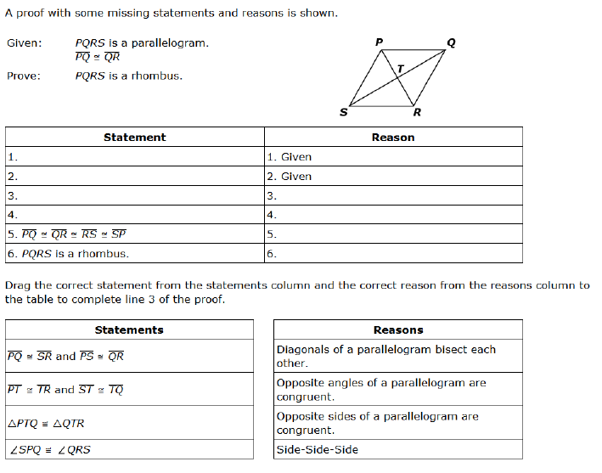
Side Side Side
Opposite sides of a parallelogram are congruent.
Opposite angles of a parallelogram are congruent.
Diagonals of a parallelogram bisect each other.
$$∠SPQ≅∆QRS$$
$$∆PTQ≅∆QTR$$
$$\overline{PT}≅\overline{TR} and \overline{ST}≅\overline{TQ}$$
$$\overline{PQ}≅\overline{SR} and \overline{PS}≅\overline{QR}$$

